Experiment 8: Modular Design of the Online Quiz System
Oct 26, 2026 · @Abhinav
Aim: To divide the Online Quiz System into modules, define interfaces and justify cohesion and coupling.
The design splits the system into 13 modules in four layers, so that each requirement in the SRS is owned by exactly one module. The requirements below are the ones the modules are traced to.

SRS requirements covered
ID | Requirement | Type
FR-01 | Users register and log in as admin, teacher or student | Functional
FR-02 | Teachers manage a question bank with categories and difficulty | Functional
FR-03 | Teachers create, schedule and publish quizzes | Functional
FR-04 | Students attempt a quiz with a countdown timer and automatic submission | Functional
FR-05 | Objective answers are graded automatically, with optional negative marking | Functional
FR-06 | Students see scores and per-question feedback after submission | Functional
FR-07 | Teachers view class performance and question statistics | Functional
FR-08 | The system flags suspicious behaviour during an attempt | Functional
FR-09 | Users receive notifications about quizzes and results | Functional
NFR-01 | Passwords are hashed and every request is authenticated | Security
NFR-02 | Sensitive actions are recorded in an audit trail | Security
NFR-03 | The timer is enforced on the server, not the browser | Reliability
NFR-04 | Support 500 simultaneous quiz attempts | Performance

8.1 Modules
The 13 modules are listed from the user-facing layer down to the reusable primitives, and each one carries the SRS requirements it implements.
Module | Package | Main responsibility | SRS
Student Web App | web/student | Browse quizzes, attempt with a live timer, view results | FR-04, FR-06
Teacher Console | web/console | Manage questions, quizzes, users and reports | FR-02, FR-03, FR-07
REST API Layer | internal/api | HTTP endpoints, request validation and wiring of modules | NFR-01
Quiz Engine | internal/quiz | Create, schedule and publish quizzes; start, save and submit attempts | FR-03, FR-04
Grading Engine | internal/grading | Auto-grade answers, apply negative marking, queue manual review | FR-05
Results and Analytics | internal/analytics | Scores, ranks, question statistics and class reports | FR-06, FR-07
Proctoring Monitor | internal/proctor | Detect tab switches, duplicate sessions and time anomalies | FR-08
User and Auth Manager | internal/auth | Registration, login, roles and session tokens | FR-01, NFR-01
Question Bank | internal/qbank | Store questions, options, answer keys, categories and difficulty | FR-02
Data Store | internal/store | Repository for users, questions, quizzes, attempts and results | NFR-04
Notification Service | internal/notify | Email and in-app notices for quizzes, results and alerts | FR-09
Audit Logger | internal/audit | Append-only record of logins, grade changes and flags | NFR-02
Server Clock | internal/clock | Authoritative time for deadlines, timers and auto-submit | NFR-03

Architecture overview
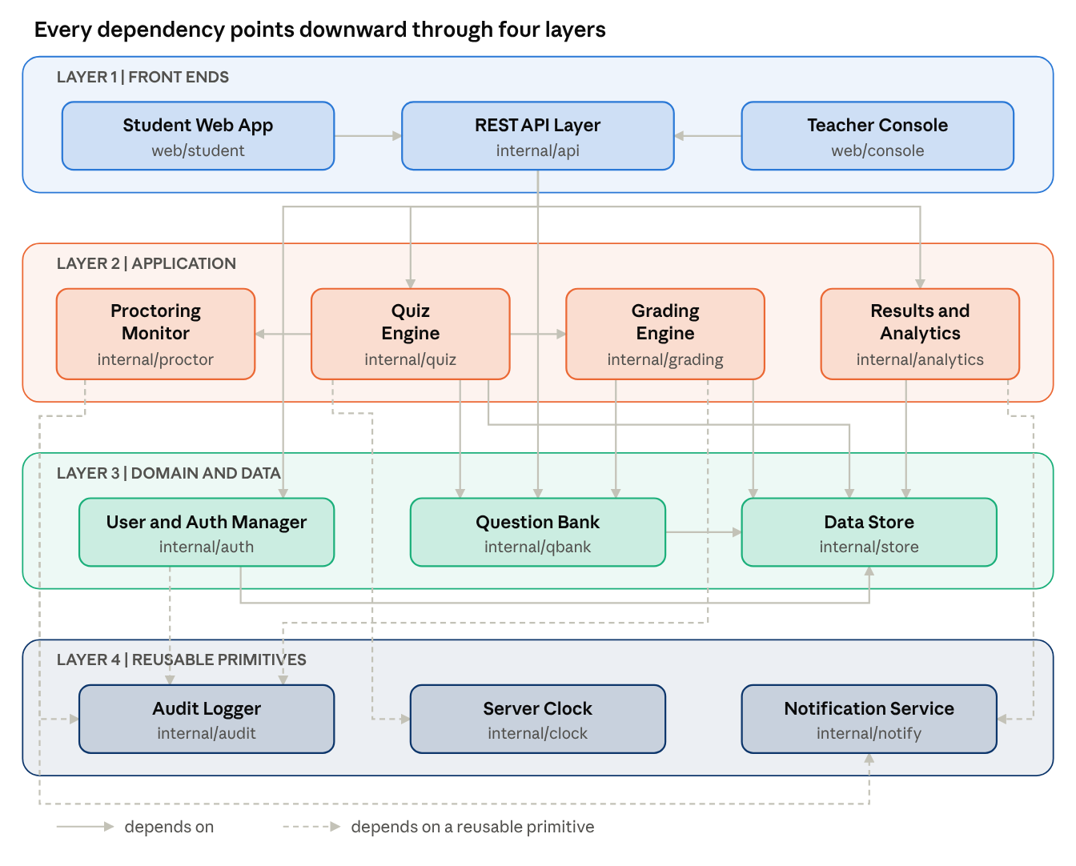
layered architecture · 13 modules, 21 dependencies
Fig. 8.1 Modular design diagram of the Online Quiz System (an arrow means depends on).

8.2 Interfaces
Six interfaces carry the main collaborations; modules talk only through these, never through each other's data.
Calling → Providing module | Interface | Input | Output
REST API Layer → Quiz Engine | StartAttempt, SaveAnswer, SubmitAttempt, GetAttemptState | quizId, studentId, questionId, answer | attemptId and remaining seconds, or error
Quiz Engine → Grading Engine | GradeAttempt | attemptId, answer sheet | total score, per-question marks
Quiz Engine, Grading Engine → Question Bank | GetQuestions, GetAnswerKey | quizId or question ids | questions without keys, or answer keys
Quiz Engine → Proctoring Monitor | ReportEvent | attemptId, event type, timestamp | status OK, WARN or FLAGGED
Quiz Engine → Server Clock | Now, DeadlineFor | start time, duration | current time, attempt deadline
Data-owning modules → Data Store | Repository: Save, FindById, Query | entity, id or filter | stored entity or result rows

8.3 Cohesion and coupling
Every module has one job: the Grading Engine only turns answers into marks, the Question Bank only stores questions and keys, and the Server Clock only tells time. Coupling is kept low because the Grading Engine receives a plain answer sheet and never imports the Quiz Engine, and because only the Data Store touches the database. The graph has 21 connections among 13 modules, so the average coupling is 21/13 = 1.62. Instability is I = Fout / (Fin + Fout), where Fin counts modules that depend on a module and Fout counts modules it depends on.
Module | Fin | Fout | I
Student Web App | 0 | 1 | 1.00
Teacher Console | 0 | 1 | 1.00
Quiz Engine | 1 | 5 | 0.83
Grading Engine | 1 | 3 | 0.75
REST API Layer | 2 | 4 | 0.67
Results and Analytics | 1 | 2 | 0.67
Proctoring Monitor | 1 | 2 | 0.67
User and Auth Manager | 1 | 2 | 0.67
Question Bank | 3 | 1 | 0.25
Data Store | 5 | 0 | 0.00
Audit Logger | 3 | 0 | 0.00
Notification Service | 2 | 0 | 0.00
Server Clock | 1 | 0 | 0.00
The pattern is the intended one: the front ends are unstable (I = 1.00) because they may change often, while the Data Store, Audit Logger, Notification Service and Server Clock are stable (I = 0.00) because many modules rely on them. All dependencies point downward, so there are no cycles.

8.4 Result
In this experiment we divided the Online Quiz System into 13 modules in four layers, traced each module to the SRS requirements it implements, defined six interfaces and checked cohesion and coupling.

